Title of Paper | Fire Standards Progress Report
Decision or Information | For information
Title and Date of Meeting | Fire Services Management Committee - July 8th, 2022
Attachments | None

Summary
This paper provides members of the Fire Commission with a summary of the progress on the Fire Standards. The Fire Standards Board last met formally on 15th June 2022.

Recommendations
Members are asked to:
- note the contents of this report for information;
- provide ongoing support to officers in enabling and empowering them to engage in the development and implementation of the Fire Standards both in production and when published; and
- encourage the monitoring of the benefits of the Fire Standards in their services.

Current Status
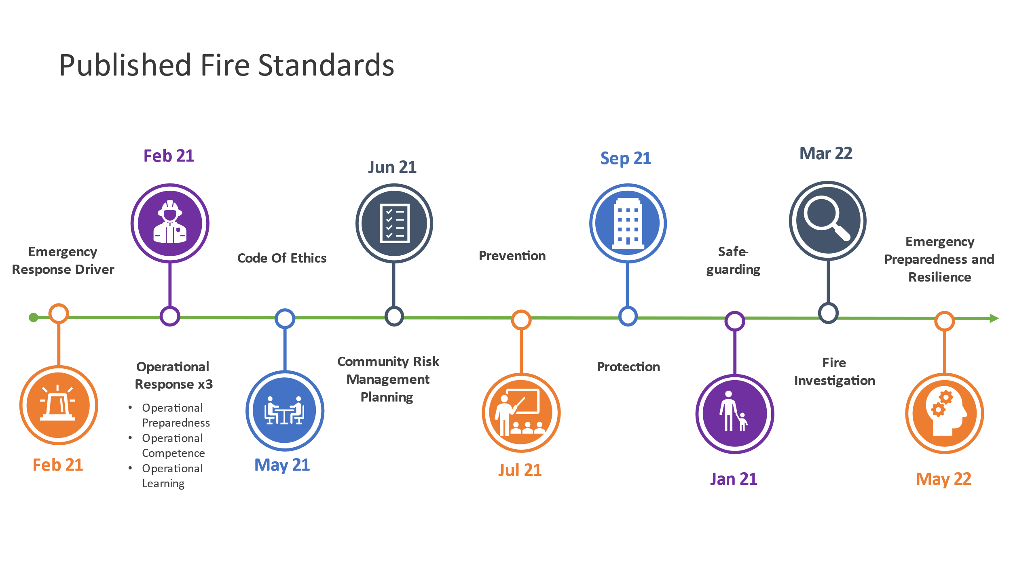There are now eleven approved and published Fire Standards which are available on the Fire Standards Board (FSB) website and shown in the timeline figure below.
The second phase of Fire Standards development is progressing with the remaining standards underway shown on the timeline diagram below, with a summary of the current status by standard:

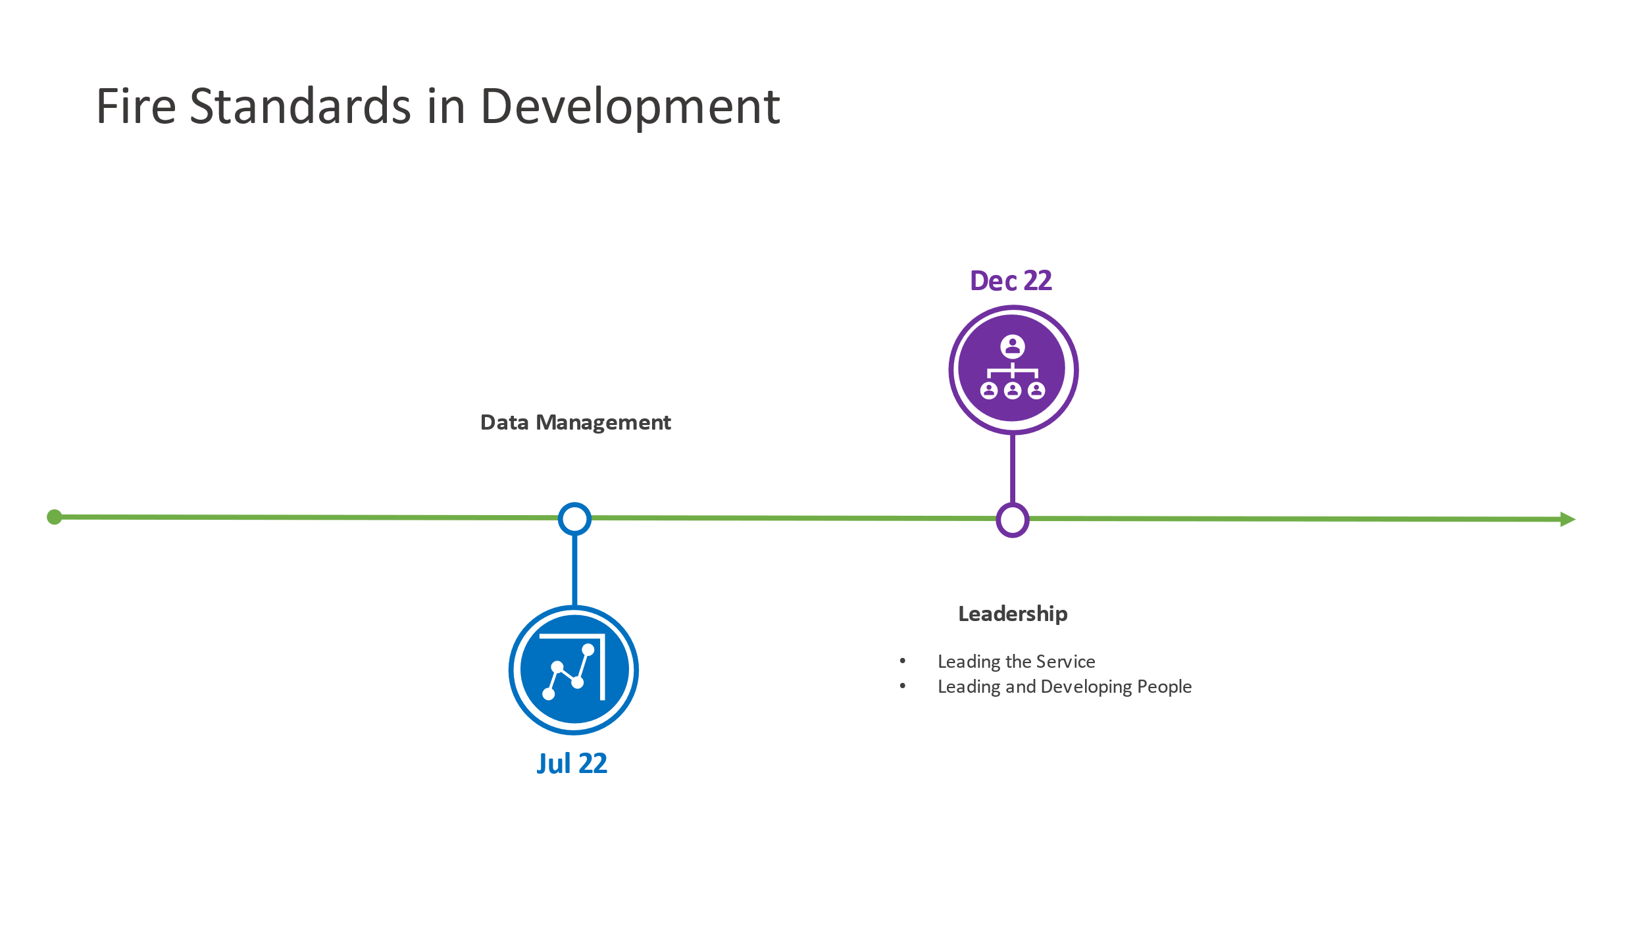

Development Update
Emergency Preparedness and Resilience
- Consultation on this standard completed in February 2022.
- Quality Assurance will be completed 23rd May and submitted to FSB for final approval.
- Published 31 May 2022.
Data Requirements and Management
- Consultation on this standard completed in May 2022.
- Analysis of the consultation responses took place during May to agree any revisions.
- The post-consultation standard was approved by the FSB for quality assurance in June 2022.
- Expected publication by July 2022.
Leadership and People Fire Standards
- Following a period of development and peer review, it has been agreed two complementary Fire Standards would be developed to cover the following;
  - Service Leadership (formerly “well-led” organisation) – setting out what an organisation that is well-led would look like and responsibilities and expectations of operational leaders
  - Leading and Developing People – setting out what good recruitment, development and management of people looks like to achieve a competent and motivated workforce
Draft Fire Standards were considered by the board and the peer group during February and March 2022, the conclusions of which were that further revisions would be required.
- Revision work took place along with benchmarking against leadership industry standards and pre-consultation drafts were produced in June 2022.
- Consultation has been approved by the Board and is currently open until September 2022.
- Subject to consultation feedback, it is expected these standards will be published by December 2022.

Remaining Areas for Consideration
A third phase of development work was approved by the FSB at the Board meeting on 15th June 2022. The Board agreed to the following standards for production as part of phase three:
No. | Activity / Potential Fire Standard | Activity Framework Category
1 | Fire Control | Service Delivery
2 | Communication, engagement, consultation | Cultural and Enabling
3 | Commercial and Procurement (Resources) | Enabling
4 | Finance and Assurance (Resources) | Enabling
5 | Asset Management (Resources) | Enabling

Health and Wellbeing has been considered during the development of the Leadership and People Fire Standards. The NFCC People Programme will be undertaking work and producing products relating to health and wellbeing, however, some of this work will not commence until 2023. Therefore, it is proposed that the need for a separate Health and Wellbeing Fire Standard will be reviewed once phase three is complete and the NFCC People Programme has progressed their programme of work.
The current focus on data for the sector is a priority, with digital and technology to follow thereafter. Therefore, work on a Fire Standard relating to digital and technology may be dependent on a variety of influences which yet are unknown. It is proposed that the progression of this work should be reviewed in 2023. The influences include, but are not limited to:
- the work of the NFCC Digital and Data Programme;
- the evolution and impact of the Emergency Service Network;
- support for services in improving local infrastructure and systems; and
- evolution of the Incident Recording System and Fire Control Room technology.
It is anticipated that the full suite of standards will total approximately 21.
The FSB has a defined periodic review process in place following publication of a Fire Standard but can initiate an exceptional review should the need arise.

Implementation support
The FSB, through the NFCC Fire Standards and Implementation Teams, will be continuing to support services as they work to achieve the Fire Standards. Implementation tools are provided with all published Fire Standards.

Impact and Benefits Realisation
The FSB are keen to understand the impact of the Fire Standards now that the first standards have been published. As part of both the development process and the consultation on each Fire Standard we ask services about potential impacts.
The FSB will be undertaking engagement activity with services during the summer 2022 to help better understand impacts and review progress to date.

Background notes for information
The Fire Standards Board (FSB) is responsible for the identification, organisation, development and maintenance of professional standards for fire and rescue services in England. Led by an independent Chair and Vice Chair, membership of the Board includes the NFCC, employers (both the LGA and the APCC) and the Home Office.
The LGA representative on the Board is Cllr Nick Chard.
The FSB continues to meet regularly to review the progress made on Fire Standards development. Its next meeting is scheduled for 9 September 2022.
Given the various stages of development required and the time needed for engagement with services in the early stages, as well as through formal consultation, development work and publications are staggered. This is primarily done to align capacity and resources in a considered way, but also to pace the rate at which standards are released to services.
Once approved, Fire Standards are shared on the Fire Standards Board website.
Services should now be aware of the requirements being placed upon them through these Fire Standards. Her Majesty’s Inspectorate of Constabulary and Fire and Rescue Services (HMICFRS) will be referencing the standards in their inspection arrangements and therefore services should be prepared to evidence their progress towards achieving them.
The Fire Standards Board would welcome and appreciate the support of fire authority chairs and members in:
- Ensuring their services are enabled to engage in Fire Standards by releasing their subject matter experts to support development work and peer review through the NFCC where appropriate and feasible.
- Responding to the Fire Standards consultations as they are published; and,
- Supporting activities to achieve those Fire Standards through implementation once approved and published.

